**AWS Task-4**

**Task Description:**

Launch an EC2 instance (Linux and Windows) along with a web server. Then, create an EBS volume of 5 GB, attach it to an EC2 machine (Linux and Windows), and take a snapshot. Finally, create an EBS volume using the taken snapshot.

===========================================================

**Launching EC2 Instance – Linux Part: -**

* 1. Logged into **AWS account.**
  2. Search **EC2** and Click **Launch instance.**

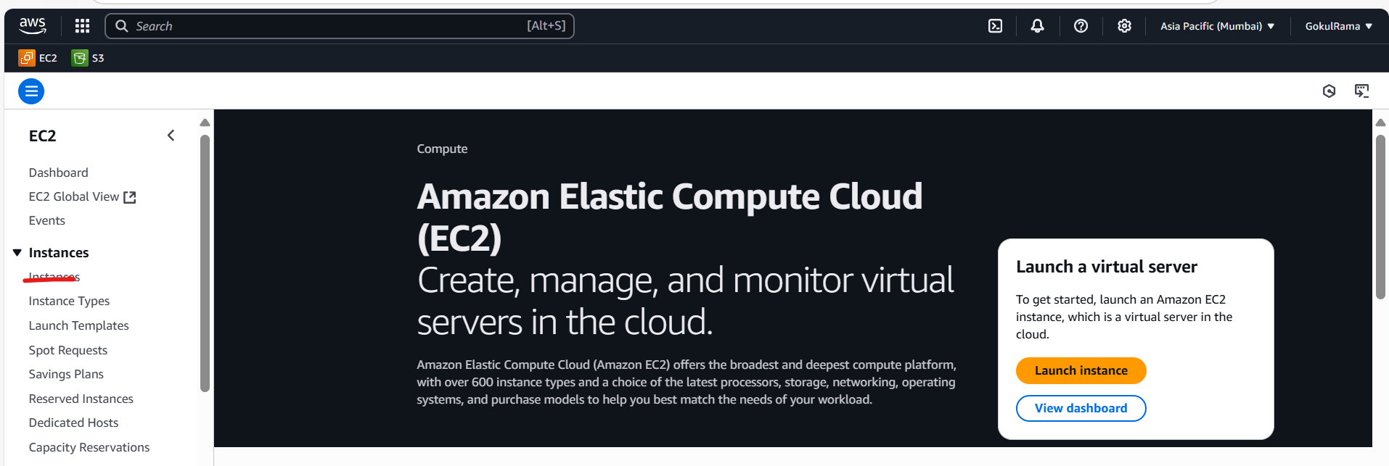

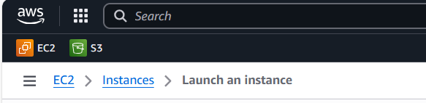

* 1. **Enter EC2 Instance Name – EC2-Linux.**

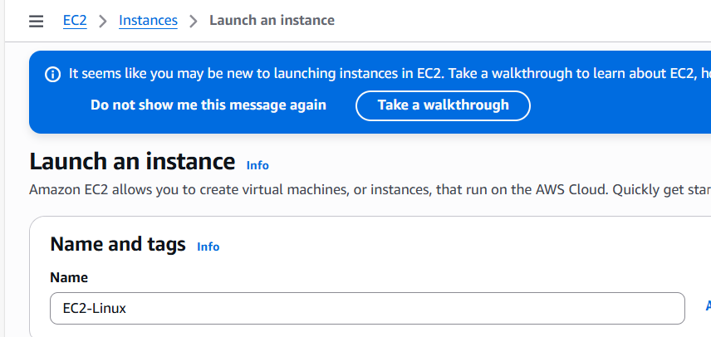

* 1. **Choose the AMI – Ubuntu**

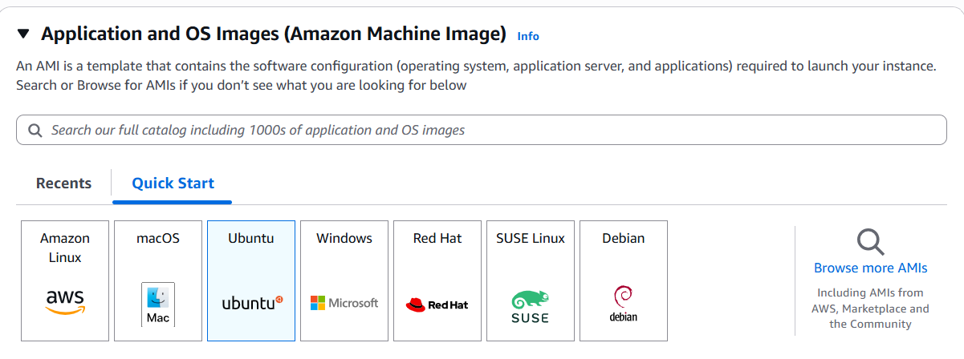

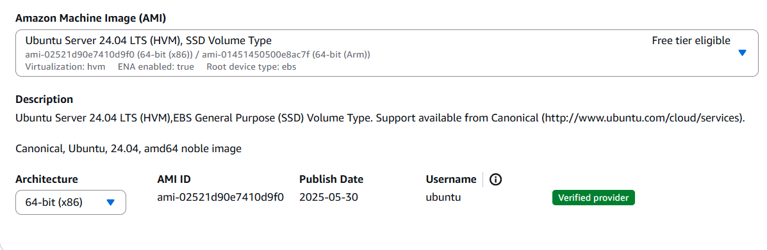

* 1. Choose **Instance Type – t2.micro** [ Free tier eligible only].
  2. Choose **already generated keypair** is **ubuntu-test**

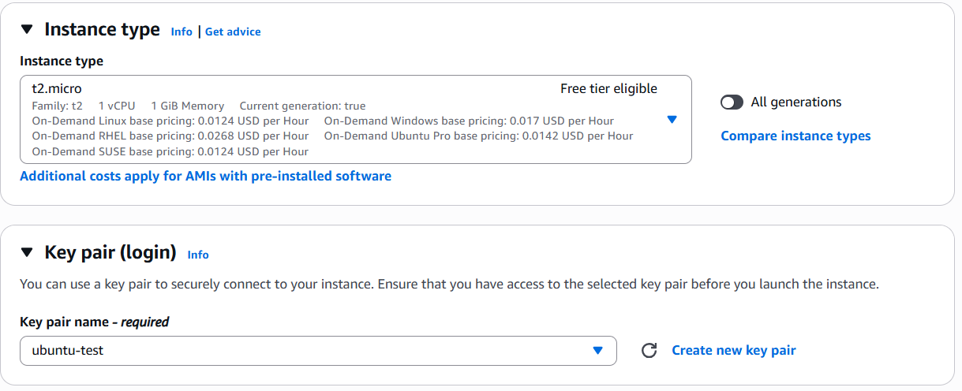

* 1. Choose **default VPC and default subnet**
  2. Select **Auto assign Public IP – Enabled**
  3. Choose **Firewall security group - Create security group**.
  4. Allow **SSH traffic, Allow HTTP traffic & Allow HTTPS traffic** should be selected

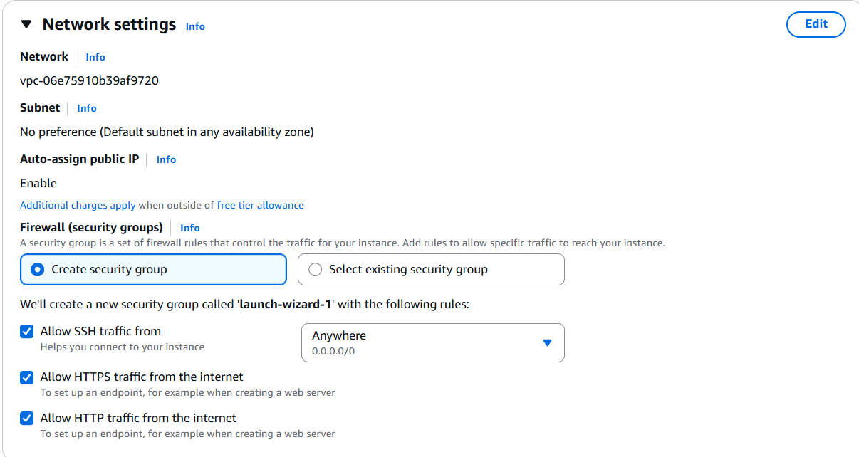

* 1. Configure **storage – default (As it is)**
  2. Click **Launch Instance**.

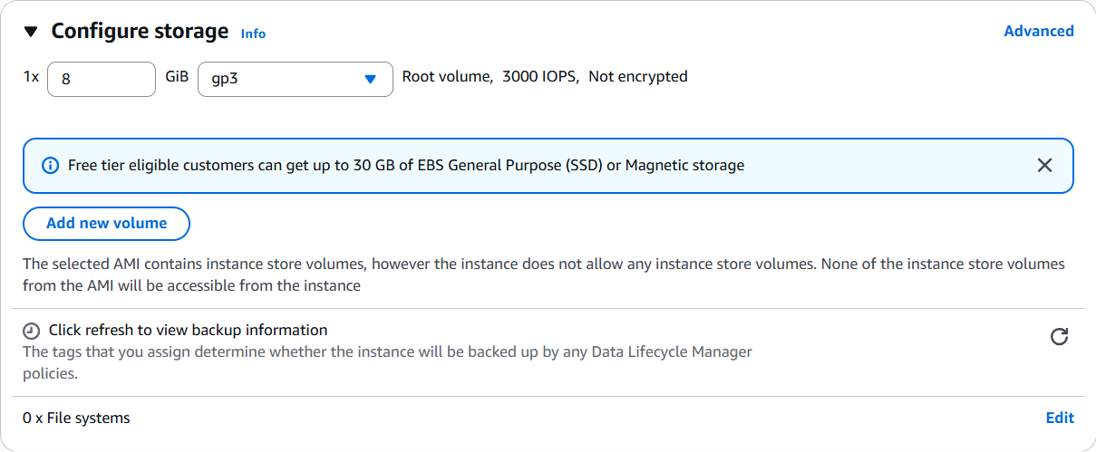



1.13 Once **EC2 instance launched successfully** looks like below,

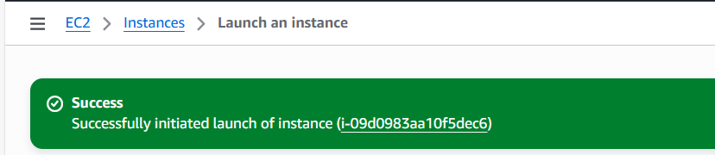

1.14 Now the **EC2 instance is Running**.

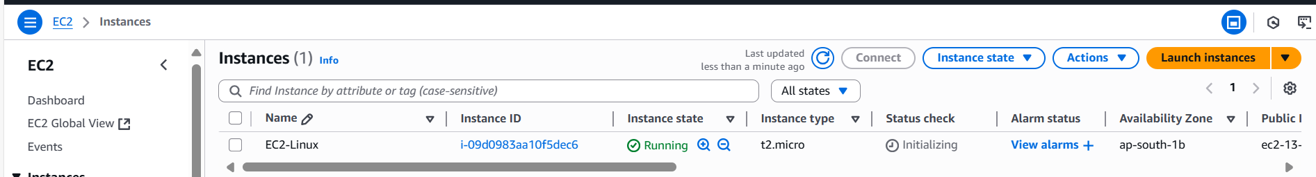

1.15 **Stop EC2 instance - > Select EC2 instance -> Go to Instance state ->**

**Choose Stop instance.**

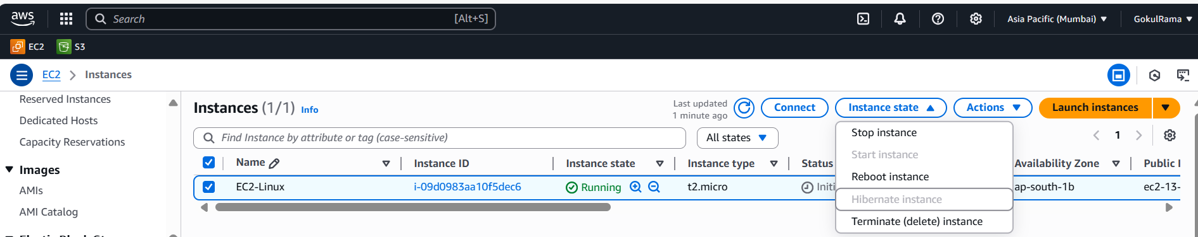

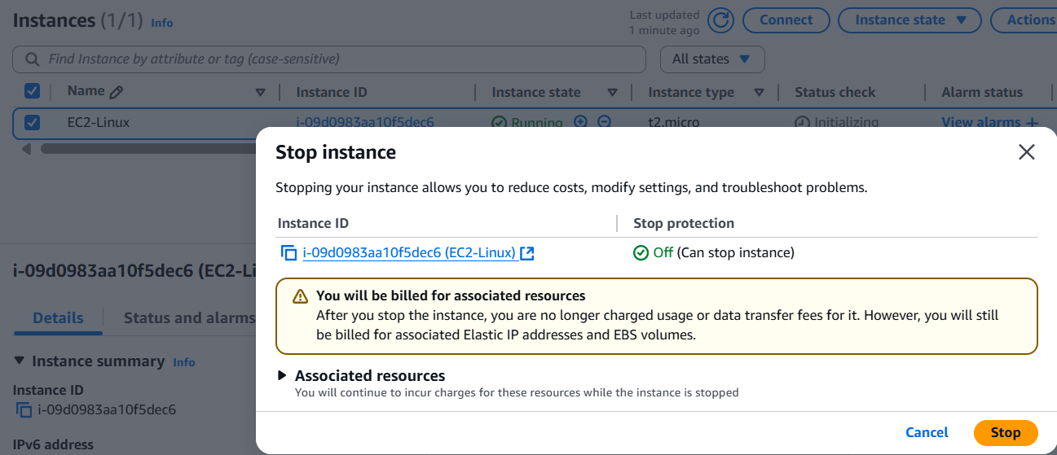

1.16 Now the **EC2 instance successfully stopped.**

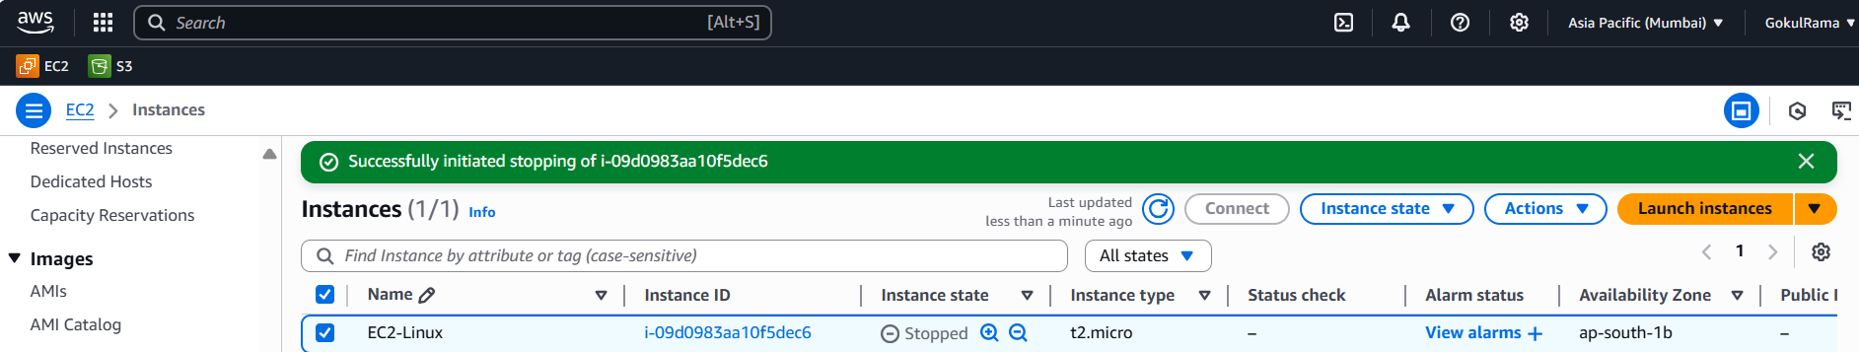

1. **Create an EBS volume of 5 GB to Linux EC2 Instance: -**
   1. Go to **Elastic Block Store (EBS)** -.> Click **Volumes** -> Click **Create Volume**

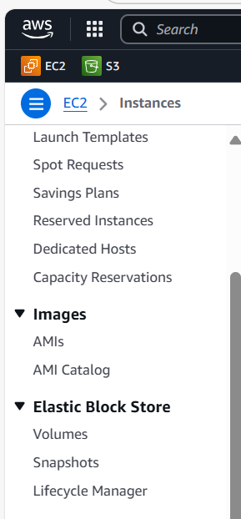

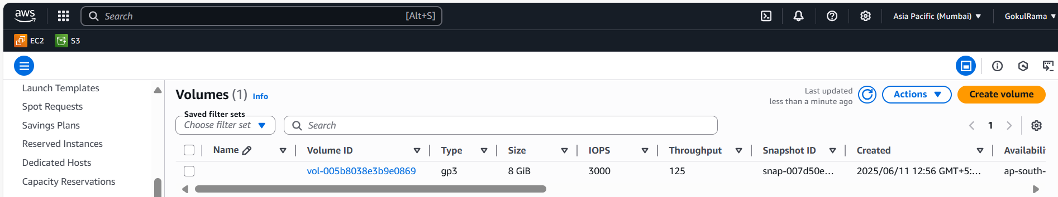

* 1. **Once Created Volume looks like below,**



* 1. **In Create Volume,**
* Choose **Volume type -> General Purpose SSD (gp3).**
* **Size – 5 GiB.**
* Choose **Availability Zone – ap-south-1b (Note – Availability Zone of EBS and EC2 instance should be same only).**
* **Remaining option should be default only.**

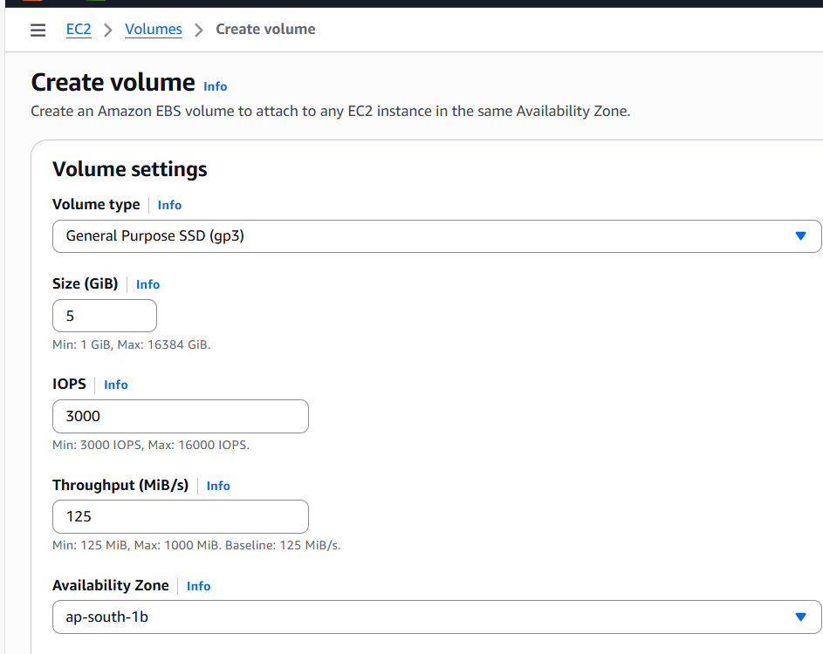

* 1. Click **Create Volume.**

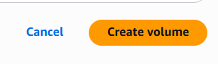

* 1. Now the **New Volume has been created.**

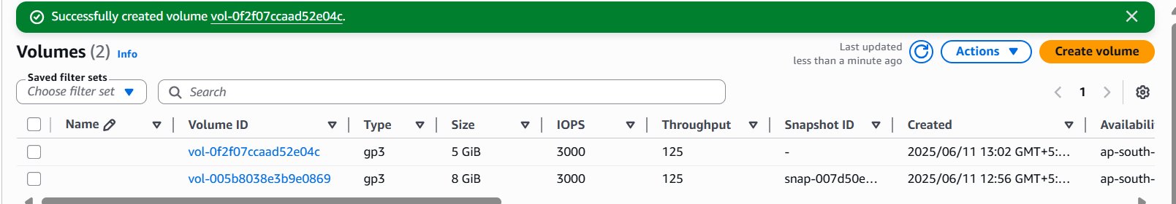

* 1. Renamed **the New Volume is EC2-Linux-NewVol.**

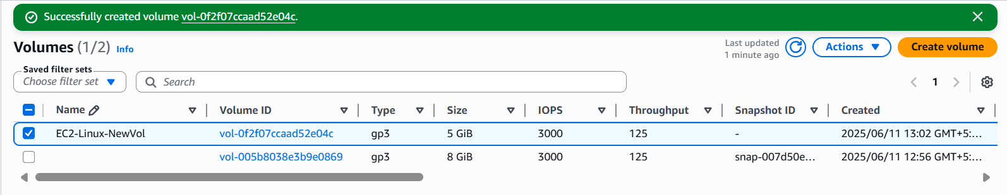

* 1. **Attach the New Volume (EC2-Linux-NewVol) to EC2 instance by using Attach Volume option [ Actions -> Attach volume].**

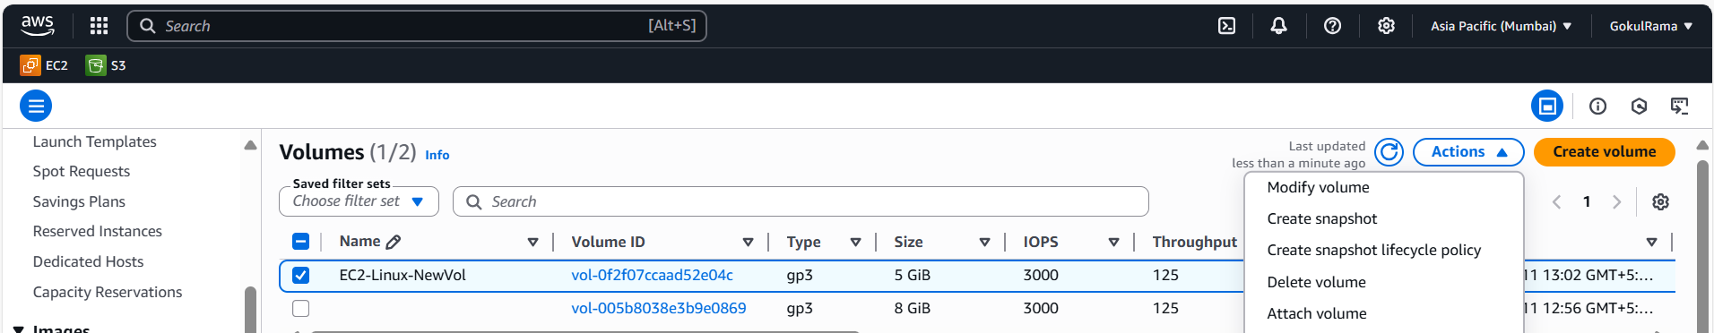

* 1. **Attach Volume configuration is,**
* Select **Instance** – Choose **respective EC2 instance.**
* **Device name** – Choose **/dev/xvdbc** (any device names its optional)
* Click **Attach volume.**

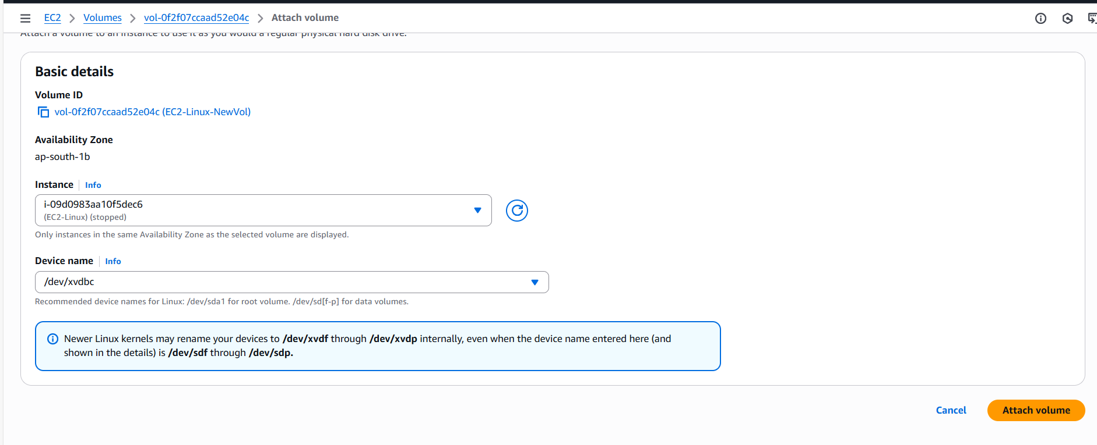

* 1. Once the **New Volume has been attached to EC2 instance -> Go back to EC2 instance screen -> Open respective EC2 instance -> Goto Storage -> See the New Volume [/dev/xvdbc] is available in EC2 instance.**

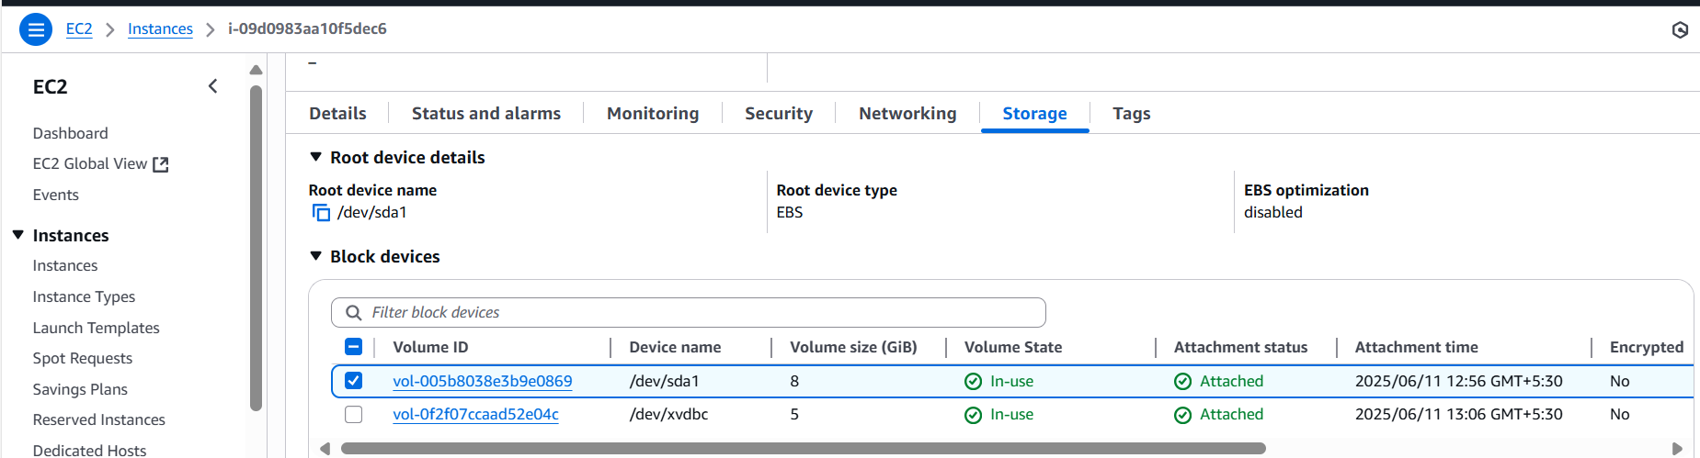

* 1. Go back to **EC2 instance screen.**

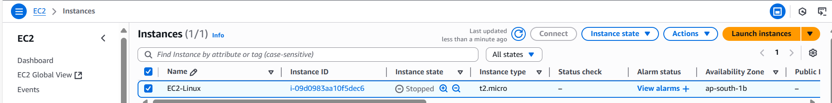

* 1. Select **respective EC2 instance (EC2-Linux) -> Go to instance state -> Select**

**Start instance.**

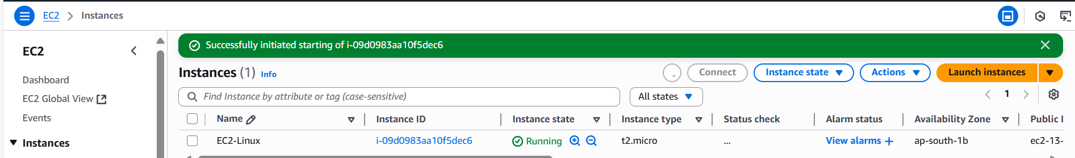

2.12 Select **EC2-Linux** instance -> Click **Connect**

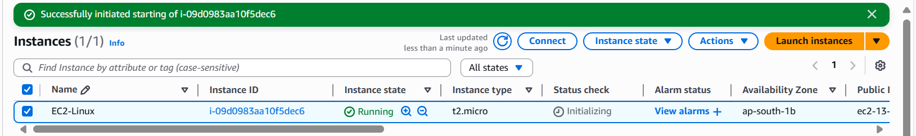

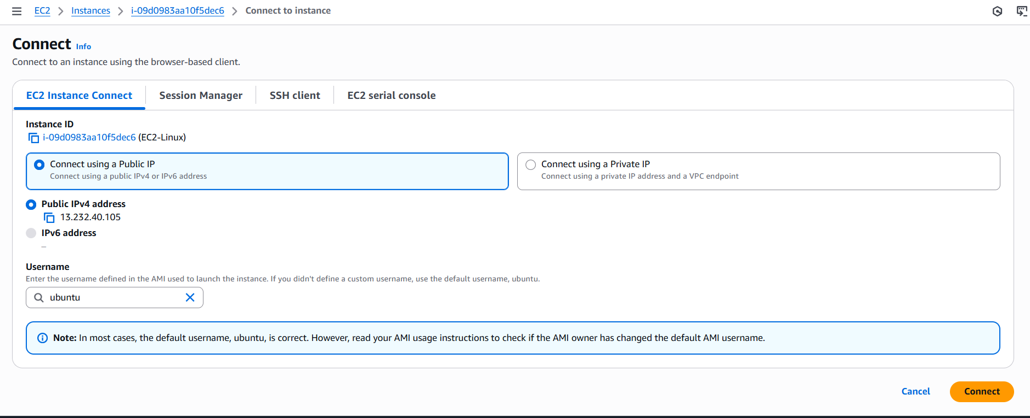

2.13 Now the **Newly created (EC2-Linux) VM has bee successfully connected**

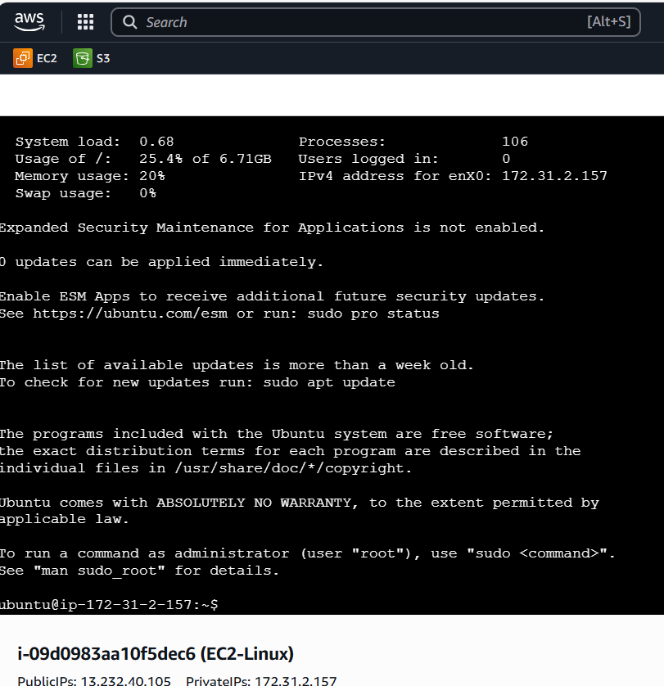

2.14 **Updating latest Linux packages** by using this command – **sudo apt update**

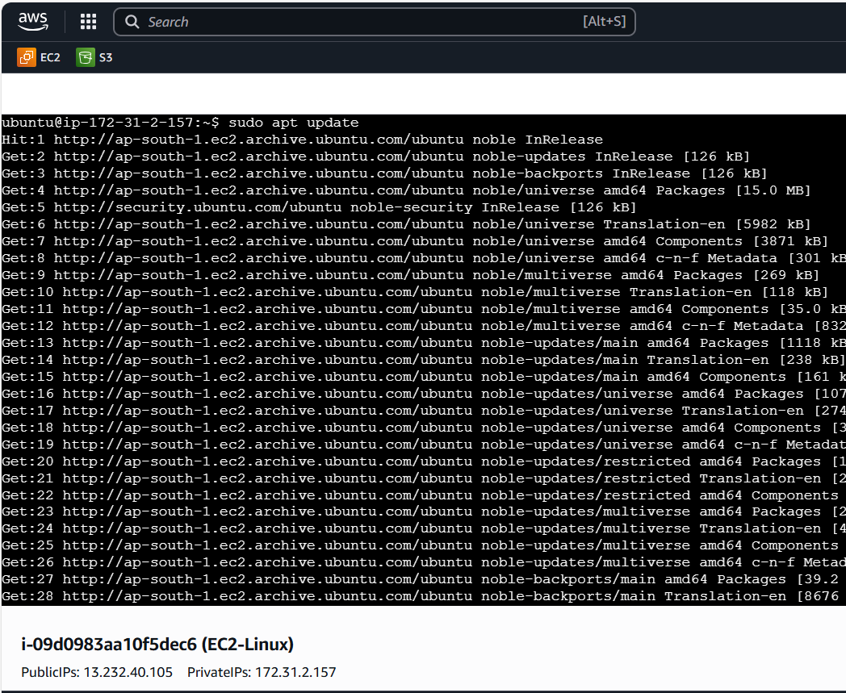

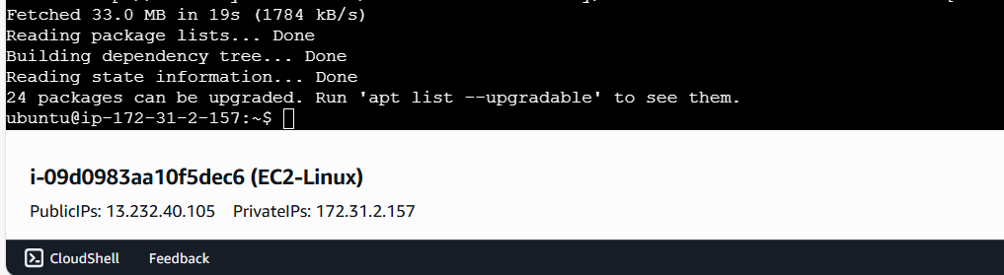

2.15 **Installing webserver (NGINX)** in **new created VM** by using this command,

Command is **sudo apt install nginx -y**

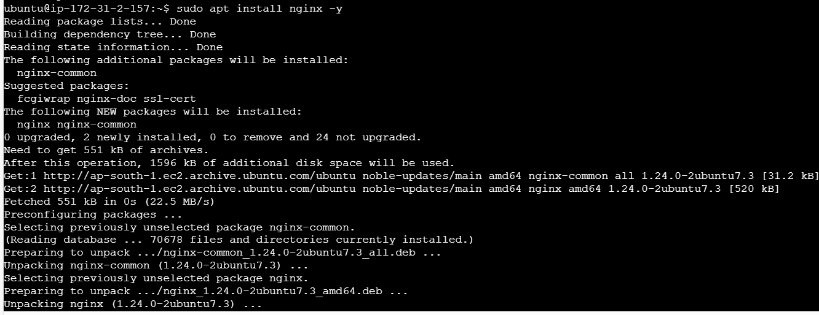

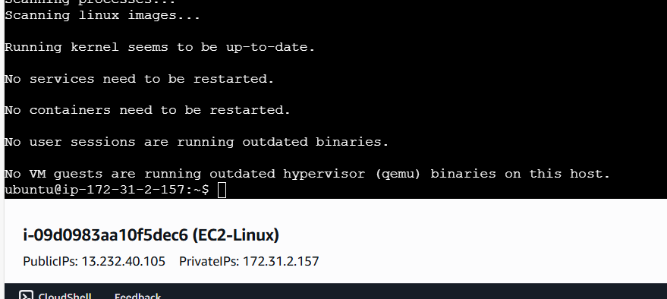

2.16 Check the **status of nginx** by using the below command,

Command is **sudo systemctl status nginx**

**Here nginx is running successfully in VM**

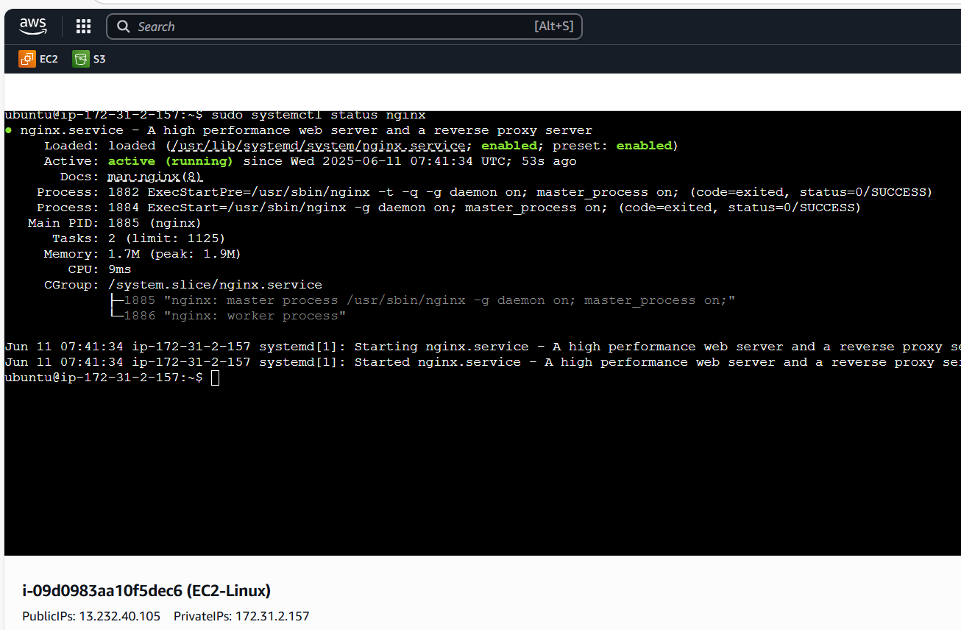

2.17 **Launch nginx** in web browser **by hitting public IP in browser [13.232.40.105]**

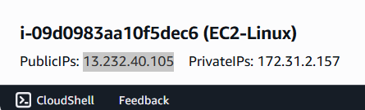

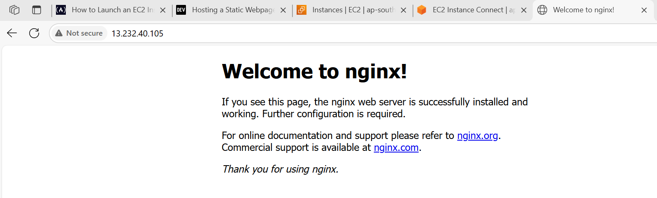

1. **Checking EBS Volume Details In VM: -**

* Using “**df-h**” command to verify available mount points.
* Here newly created “**New Volume (/dev/xvdbc)** is not visible.

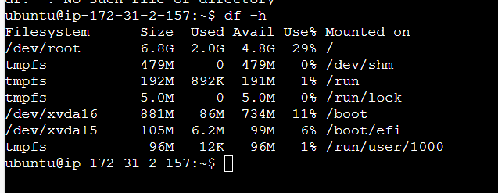

* **To verify the new volume** by using this command is **lslbk**
* New volume is listed here but there is no mount point.
* So, need to make use of this new volume need to do mounting

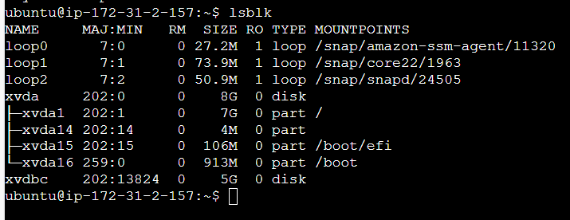

* **Before creating the mount point** need to **format the filesystem** by using this command,

**Sudo mkfs -t ext4 /dev/xvdbc**

**Ext4 is** linux default filesystem

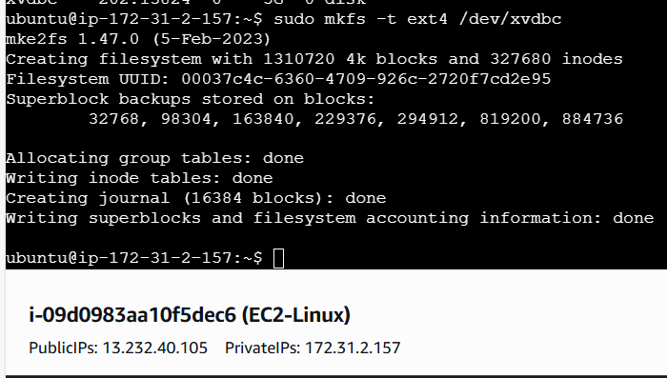

* Creating mount to the new filesystem by using the below commands,

sudo mkdir /mnt/ebs-new

sudo mount /dev/xvdbc /mnt/ebs-new

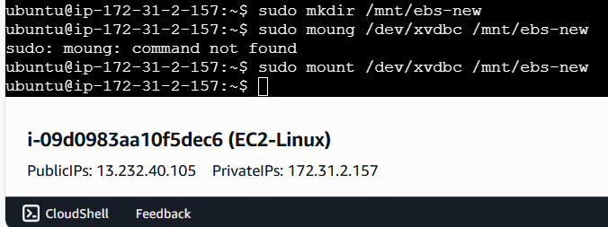

* **EBS Snapshot: -**

Enter “**df-h**” command to see created mount point**(/mnt/ebs-new**) to new filesystem **(/dev/xvdbc**) with 5GB Size

